탄성운동 Animation 예제 소스

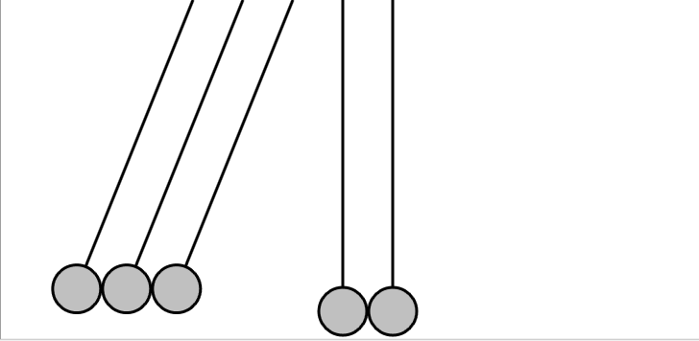

<!-- ================================================

NewtonsCradle.xaml (c) 2006 by Charles Petzold

================================================ -->

<Page xmlns="http://schemas.microsoft.com/winfx/2006/xaml/presentation"

xmlns:x="http://schemas.microsoft.com/winfx/2006/xaml"

Title="Newton's Cradle"

WindowTitle="Newton's Cradle by Charles Petzold">

<Canvas>

<Canvas.Resources>

<Style TargetType="{x:Type Path}">

<Setter Property="Stroke" Value="Black" />

<Setter Property="StrokeThickness" Value="3" />

<Setter Property="Fill" Value="Silver" />

<Setter Property="Data"

Value="M 0 0 V 300 A 25 25 0 1 1 0 350

A 25 25 0 1 1 0 300" />

</Style>

</Canvas.Resources>

<Path>

<Path.RenderTransform>

<TransformGroup>

<RotateTransform x:Name="xform1" Angle="30" />

<TranslateTransform X="200" />

</TransformGroup>

</Path.RenderTransform>

</Path>

<Path>

<Path.RenderTransform>

<TransformGroup>

<RotateTransform x:Name="xform2" Angle="30" />

<TranslateTransform X="252" />

</TransformGroup>

</Path.RenderTransform>

</Path>

<Path>

<Path.RenderTransform>

<TransformGroup>

<RotateTransform x:Name="xform3" Angle="30" />

<TranslateTransform X="304" />

</TransformGroup>

</Path.RenderTransform>

</Path>

<Path>

<Path.RenderTransform>

<TransformGroup>

<RotateTransform x:Name="xform4" />

<TranslateTransform X="356" />

</TransformGroup>

</Path.RenderTransform>

</Path>

<Path>

<Path.RenderTransform>

<TransformGroup>

<RotateTransform x:Name="xform5" />

<TranslateTransform X="408" />

</TransformGroup>

</Path.RenderTransform>

</Path>

<Canvas.Triggers>

<EventTrigger RoutedEvent="Page.Loaded">

<BeginStoryboard>

<Storyboard TargetProperty="Angle" RepeatBehavior="Forever">

<DoubleAnimationUsingKeyFrames Storyboard.TargetName="xform1">

<DiscreteDoubleKeyFrame KeyTime="0:0:0" Value="30" />

<SplineDoubleKeyFrame KeyTime="0:0:1" Value="0"

KeySpline="0.25 0, 0.6 0.2" />

<DiscreteDoubleKeyFrame KeyTime="0:0:3" Value="0" />

<SplineDoubleKeyFrame KeyTime="0:0:4" Value="30"

KeySpline="0.75 1, 0.4 0.8" />

</DoubleAnimationUsingKeyFrames>

<DoubleAnimationUsingKeyFrames Storyboard.TargetName="xform2">

<DiscreteDoubleKeyFrame KeyTime="0:0:0" Value="30" />

<SplineDoubleKeyFrame KeyTime="0:0:1" Value="0"

KeySpline="0.25 0, 0.6 0.2" />

<DiscreteDoubleKeyFrame KeyTime="0:0:3" Value="0" />

<SplineDoubleKeyFrame KeyTime="0:0:4" Value="30"

KeySpline="0.75 1, 0.4 0.8" />

</DoubleAnimationUsingKeyFrames>

<DoubleAnimationUsingKeyFrames Storyboard.TargetName="xform3">

<DiscreteDoubleKeyFrame KeyTime="0:0:0" Value="30" />

<SplineDoubleKeyFrame KeyTime="0:0:1" Value="0"

KeySpline="0.25 0, 0.6 0.2" />

<SplineDoubleKeyFrame KeyTime="0:0:2" Value="-30"

KeySpline="0.75 1, 0.4 0.8" />

<SplineDoubleKeyFrame KeyTime="0:0:3" Value="0"

KeySpline="0.25 0, 0.6 0.2" />

<SplineDoubleKeyFrame KeyTime="0:0:4" Value="30"

KeySpline="0.75 1, 0.4 0.8" />

</DoubleAnimationUsingKeyFrames>

<DoubleAnimationUsingKeyFrames Storyboard.TargetName="xform4">

<DiscreteDoubleKeyFrame KeyTime="0:0:0" Value="0" />

<DiscreteDoubleKeyFrame KeyTime="0:0:1" Value="0" />

<SplineDoubleKeyFrame KeyTime="0:0:2" Value="-30"

KeySpline="0.75 1, 0.4 0.8" />

<SplineDoubleKeyFrame KeyTime="0:0:3" Value="0"

KeySpline="0.25 0, 0.6 0.2" />

</DoubleAnimationUsingKeyFrames>

<DoubleAnimationUsingKeyFrames Storyboard.TargetName="xform5">

<DiscreteDoubleKeyFrame KeyTime="0:0:0" Value="0" />

<DiscreteDoubleKeyFrame KeyTime="0:0:1" Value="0" />

<SplineDoubleKeyFrame KeyTime="0:0:2" Value="-30"

KeySpline="0.75 1, 0.4 0.8" />

<SplineDoubleKeyFrame KeyTime="0:0:3" Value="0"

KeySpline="0.25 0, 0.6 0.2" />

</DoubleAnimationUsingKeyFrames>

</Storyboard>

</BeginStoryboard>

</EventTrigger>

</Canvas.Triggers>

</Canvas>

</Page>